**12. Demonstrate how test scripts are written in Postman.**

**##Test scripts are written in Postman and Chaining**

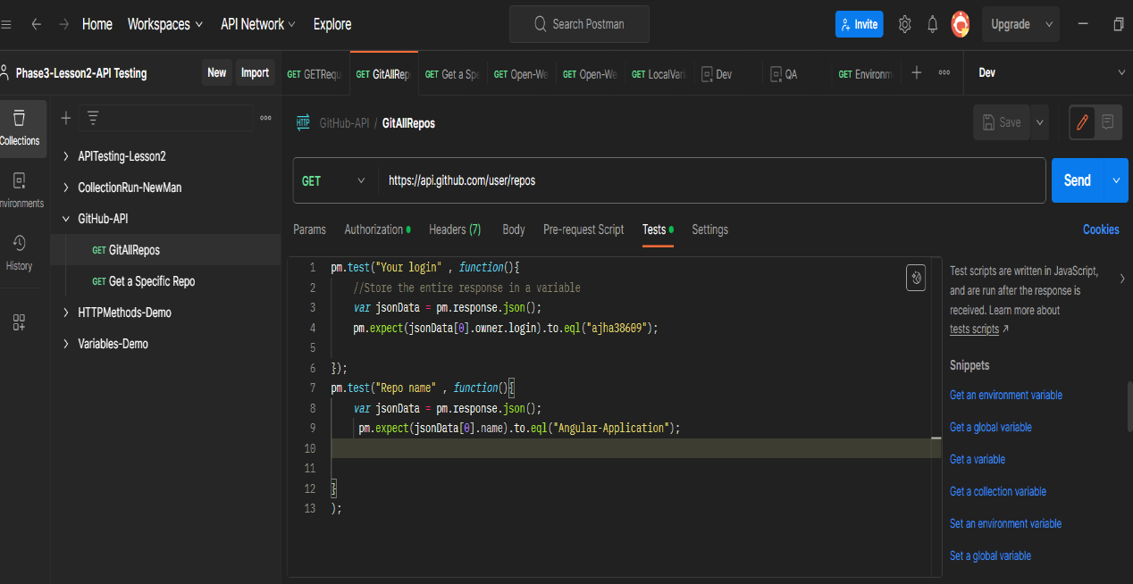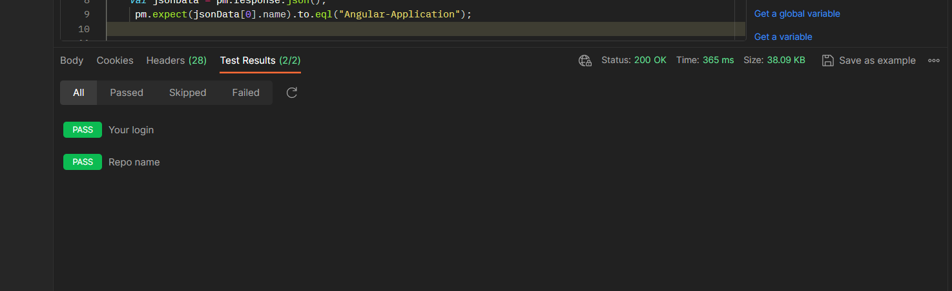

**@Creating a new repo by PostMan**

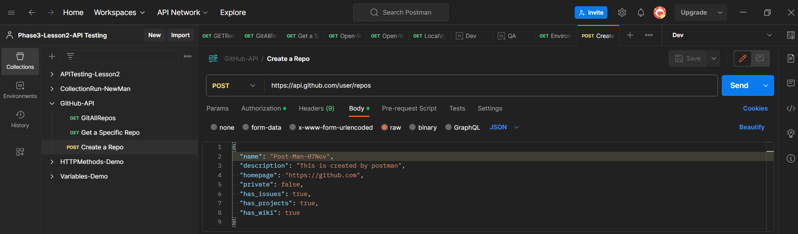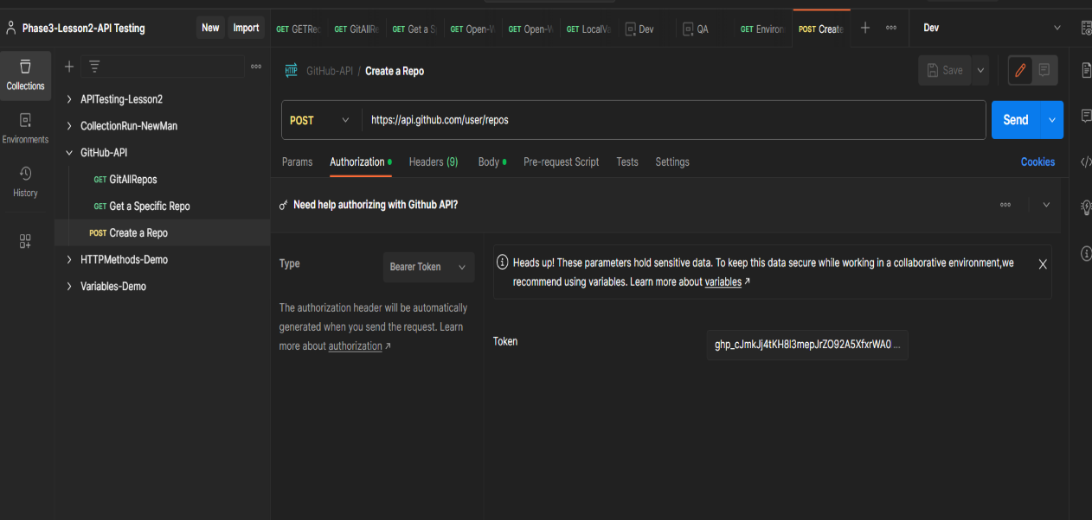

**@Create a new repo with random name with**

**Variables**

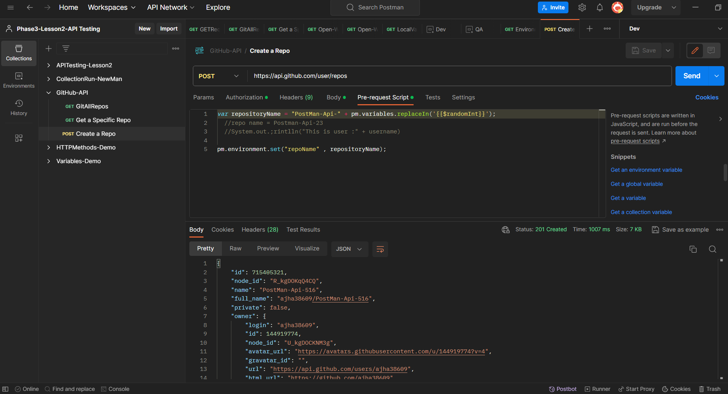

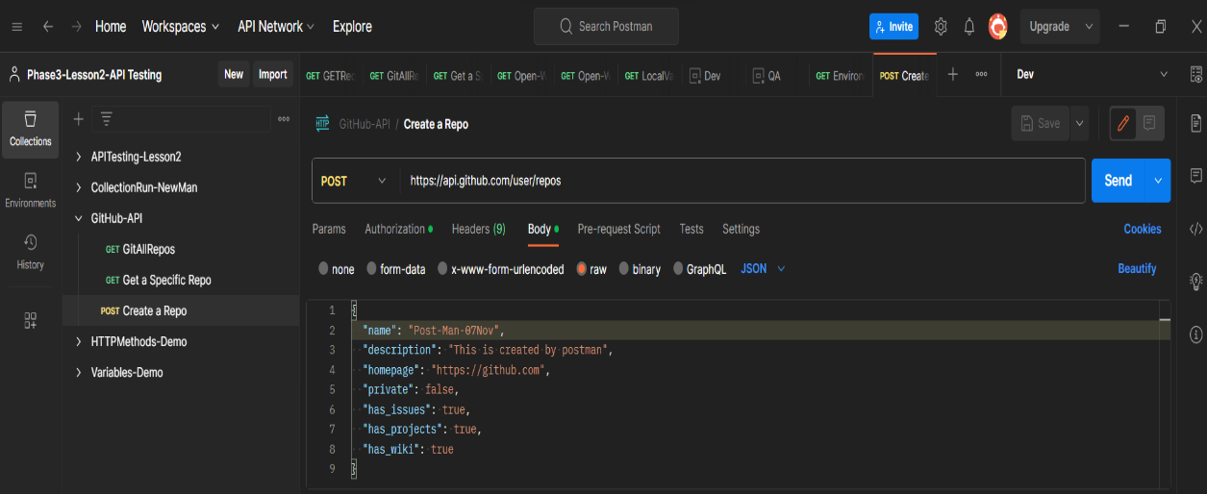

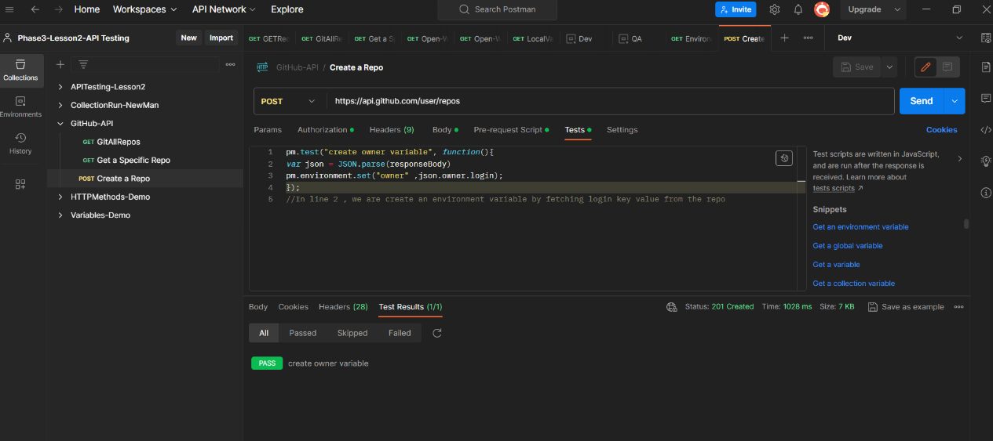

**## Chaining The Request**

**@ Fetch a repo with the help of previously create a variable and new repo with random name (Chaining)**

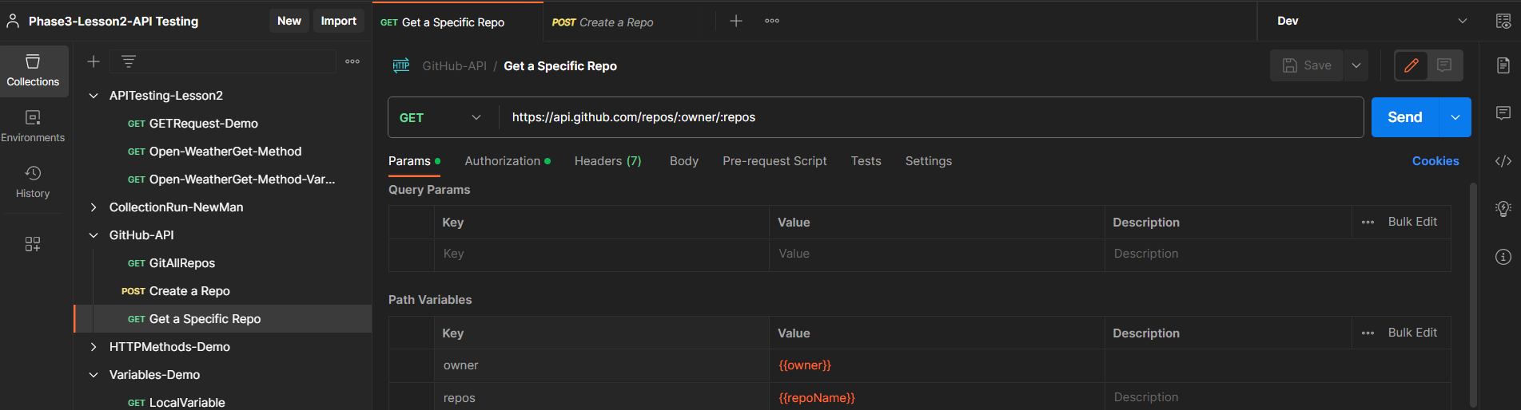

**@ GITHUB get request Test (Assertion)**

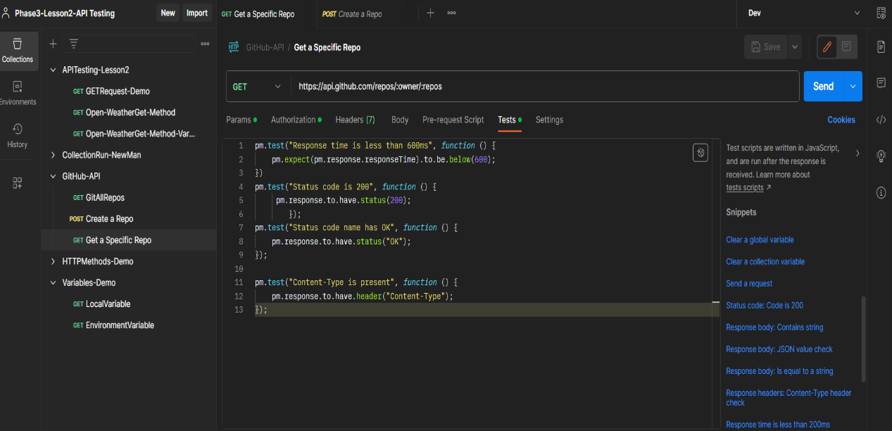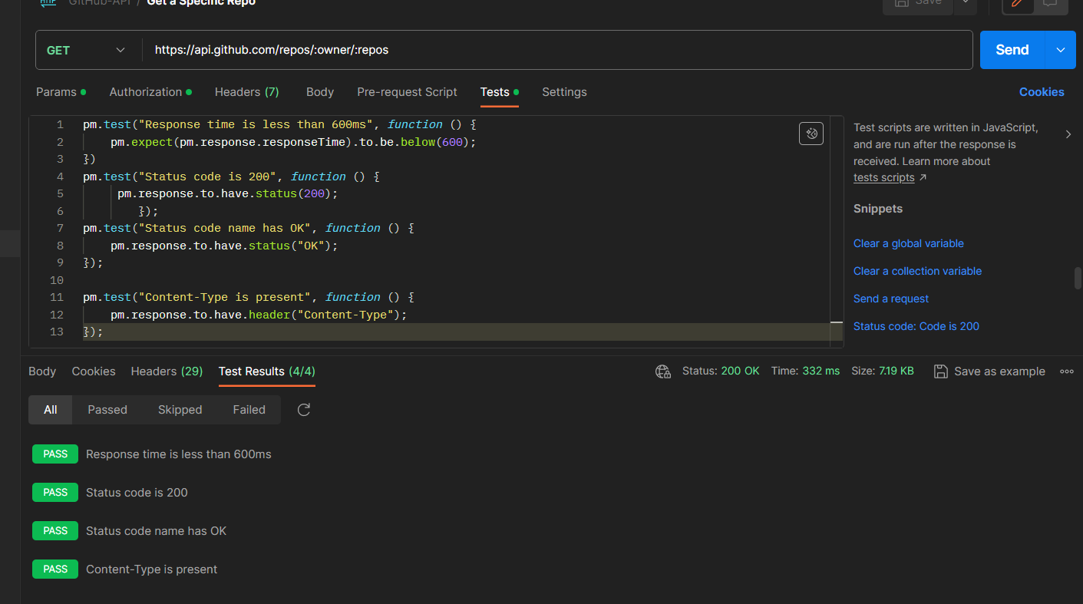

**@Deleting Request**

